**Task:**

**STATIC FOOD ORDERING WEBSITE USING HTML AND CSS**

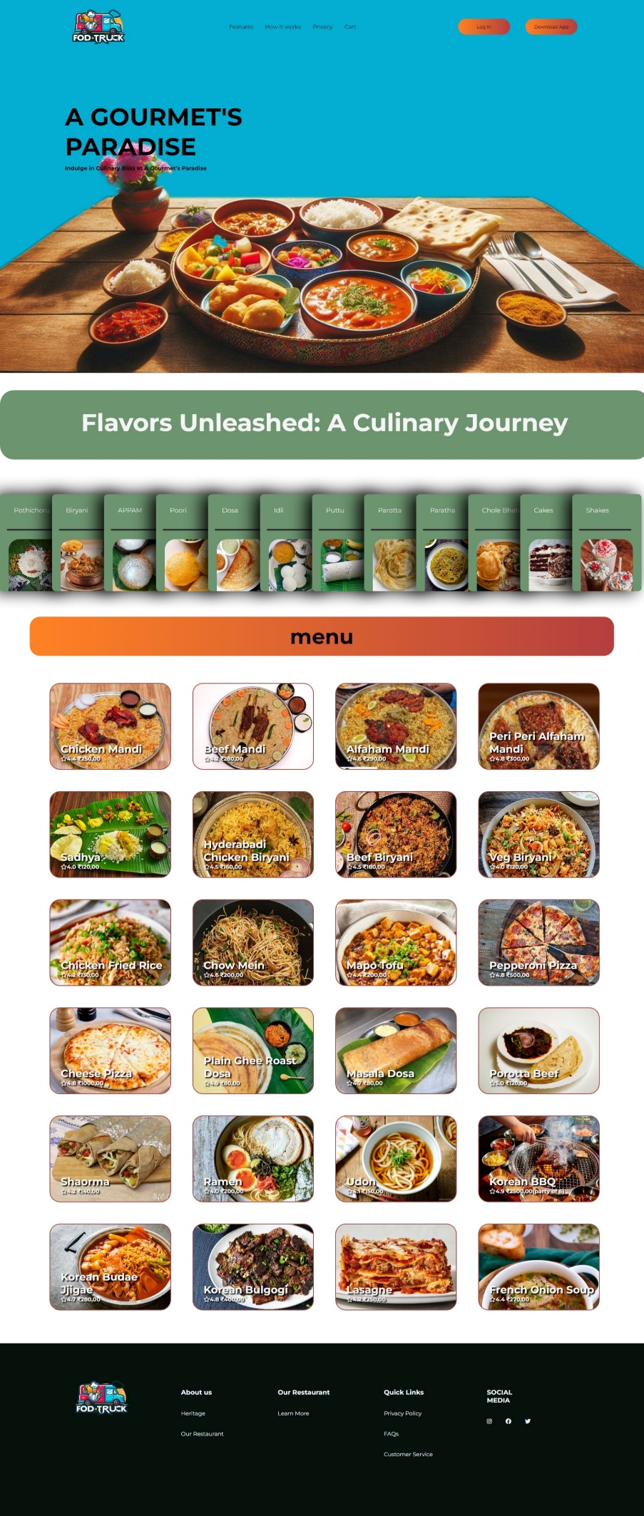

**HIPERLINKED WEB PAGES:**

**1, LOGIN PAGE:**

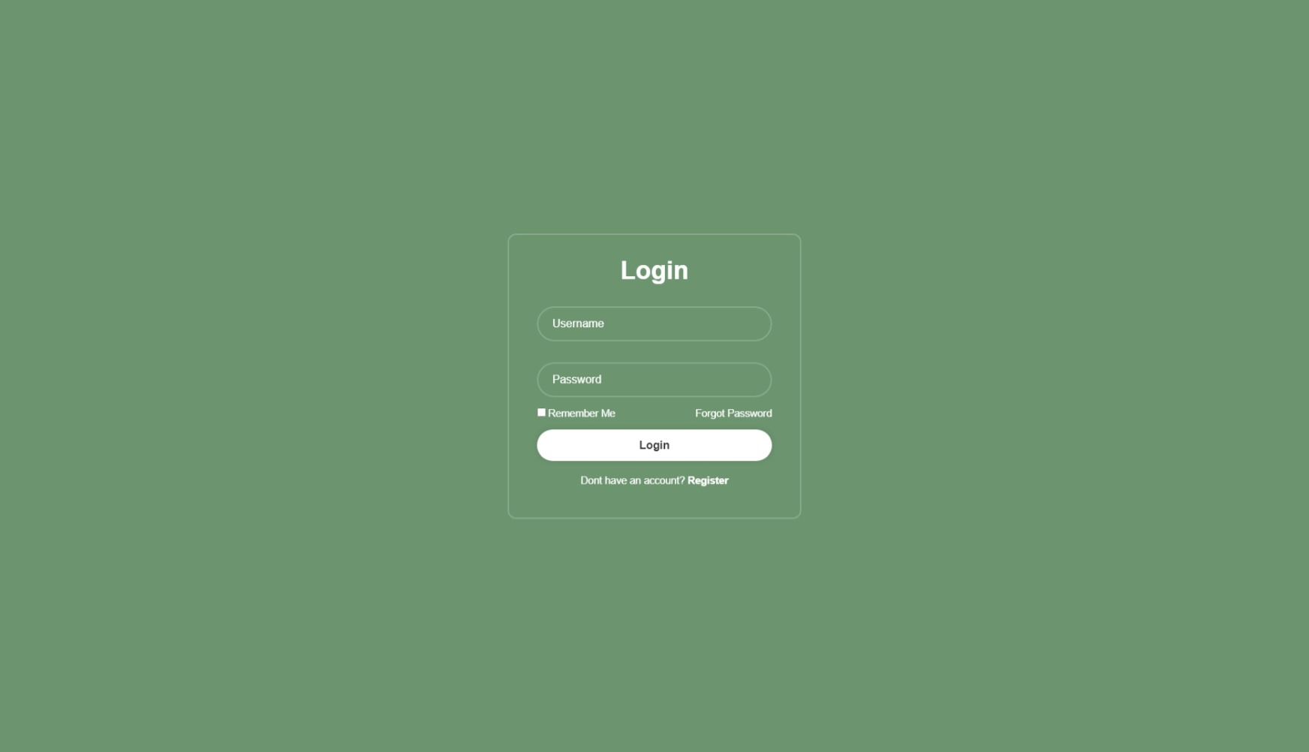

**2, ABOUT US:**

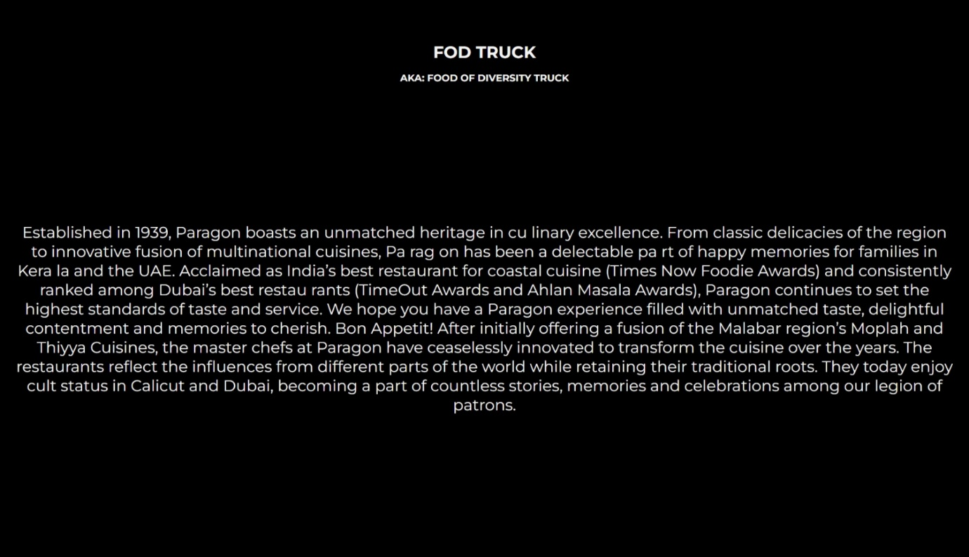

**3, FEEDBACK AND CONTACT PAGE:**

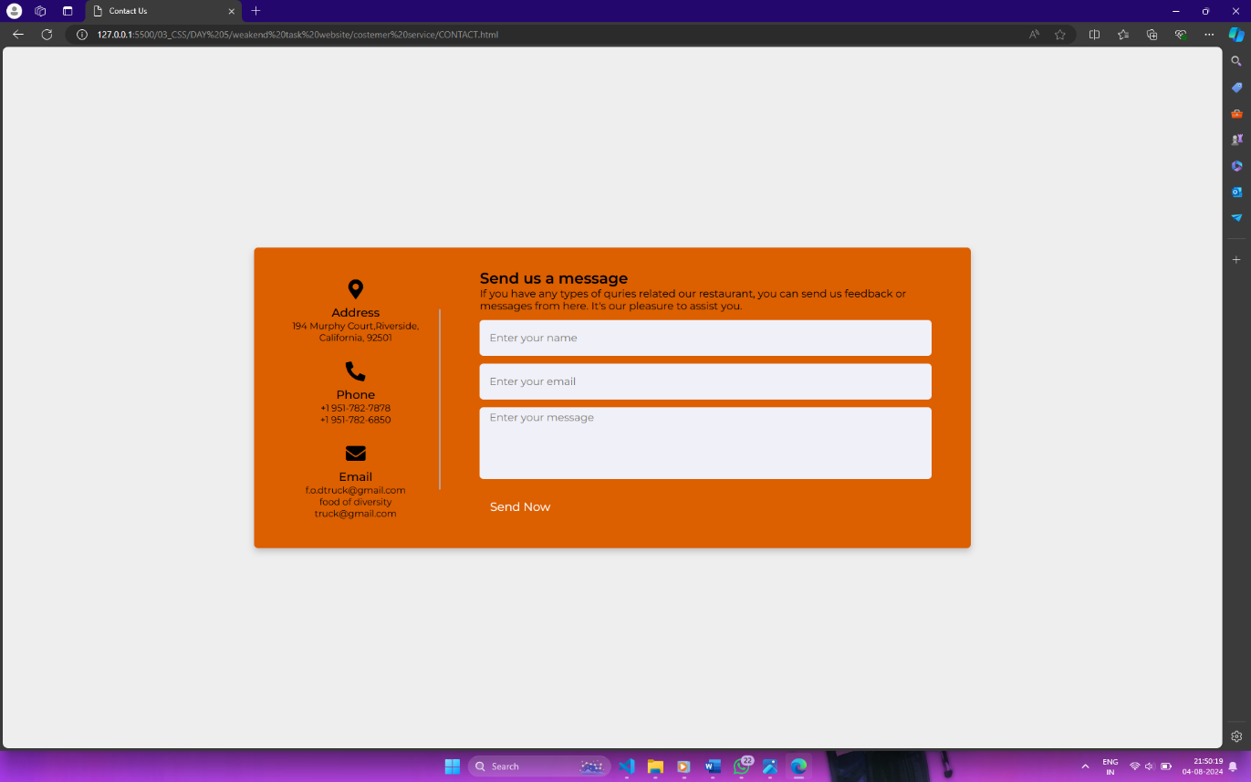

**ANIMATIONS ADDED:**

**1, LOGIN AND DOWNLOAD BUTTON:**

Before hover:

After hover:



**2, CATEGORY CARD POPUP ANNIMATION:**

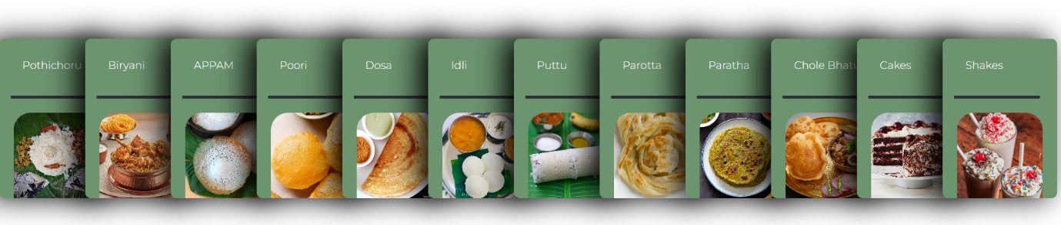Before hover:

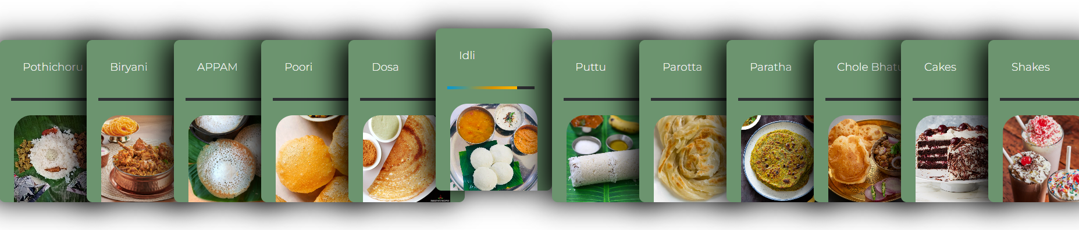After hover:

**3, MENU ITEMS POP UP ANIMATION:**

Before hover:

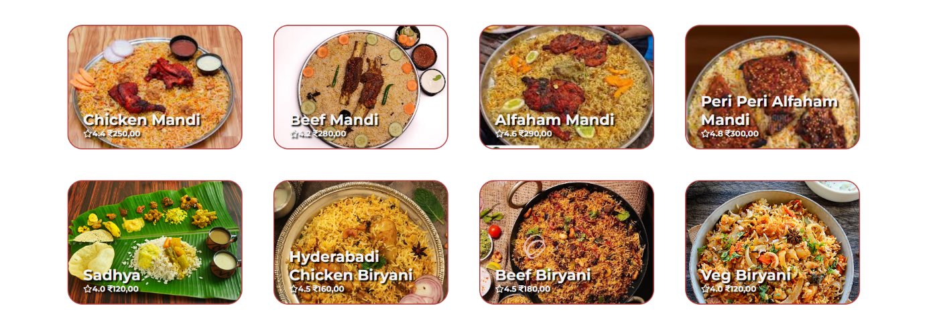

After hover:

